Project Design Phase-I Problem Solution Fit

|  |  |
| --- | --- |
| **Date** | **16 October 2022** |
| **Team ID** | **PNT2022TMID30647** |
| **Project Name** | **IoT based smart crop protection system for agriculture** |

**TEAM LEAD:**

S.MONIKA

**TEAM MEMBERS:**

T.CHARU VIKASHINI

N.AKSHAYA

R.SOORYA PRIYA

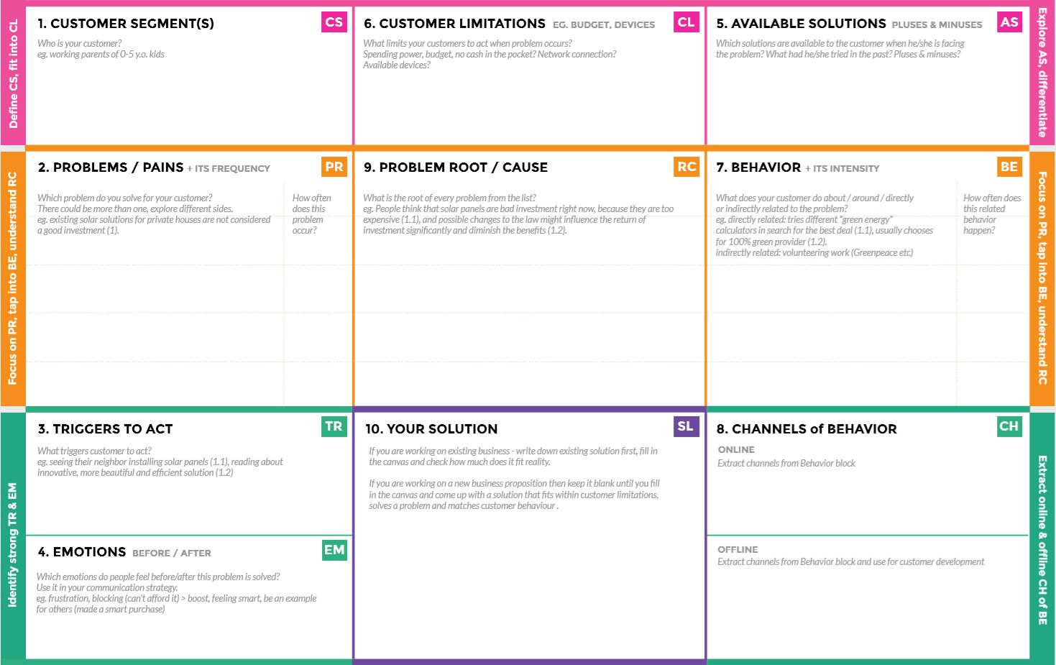

J# If temperature ,PH level, humidity & light intensity makes the serious cause for the environment.

# Farmer affected by less productivity which will affect in their profit

***# “IOT BASED SMART CROP PROTECTION SYSTEM FOR AGRICULTURE”!!***

***It helps farmers grow more food on less land by protection crops from pests , diseases and weeds as well as raising productivity per hectare***

**# Before: Finances , heavy work overload and conflict in relationship.**

**#After: It will easier to make more yield.**

**# Offline: The control action is taken by the farmers to monitor the farms .**

**# Online: The data send through applications for the farmers to know about the farms.**

**# Create opportunities to lift people out of poverty in developing nations(Over 60%)**

**#Direct related : Tries to find a solution to prevent this problem.**

**#Indirect problem : Located in rural where internet connectivity might not be strong enough to facilitate fast transmission speeds.**

**# It’s difficult to monitor and control.**

**# Ain ’t known if the application doesn’t work properly**.

**# Monitor different parameters and mobile or web application make easily to farm the crop field.**

**# Certain cultural practices can prevent or reduce insect damage**.

**# High costs.**

**# Modern Technologies**

**# Sensor and camera**

**# Farmers, who’s not near this field.**

**# Crop importers**